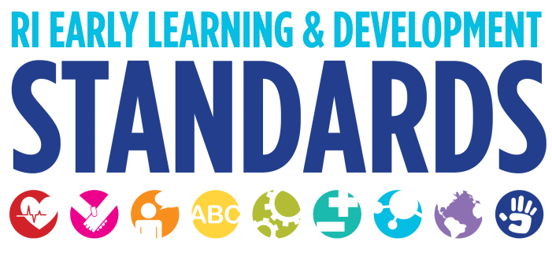
Strategies that Support Children in the Area of Creative Arts

Experimentation and Participation in the Creative Arts
- Babies enjoy looking at colors. You can enhance this experience by taping tissue paper to the windows or hanging mobiles safely within view.
- Play a variety of music for babies (children’s sing alongs, lullabies etc.)
- Use props in which toddlers and preschools can make their own music (scarves, maracas, drums, tambourines etc.)
- With infants and toddlers use bandanas, soft scarves or fabric swatches to dangle above baby to track, bat at, and grab; feel and snuggle, explore textures; play peek-a-boo; use to fill and empty tissue boxes.
- Use tissue box blocks (fill with recyclable paper or junk mail to add weight, seal with construction or laminating paper and clear non-toxic packing tape) to stack, bang on boxes, build and knock down (cause and effect), explore concepts of shape, size, color, weight.
- With infants and toddlers use sanitized throw-able items such as shower puffs, pot scrubbers, wiffle balls, sock balls or fabric shapes to put in mouth, bang together, dump and fill, throw or roll; use in water; use puffs, scrubbers, wiffle balls for painting; explore concepts of size, shape, color texture; sort and classify by size, shape, color, texture.
- Maintain a supportive atmosphere in which all forms of creative expression are encouraged, accepted and valued. Participation in any art activity should always be a choice. There is no wrong answer.
- With toddlers and preschoolers use three dimensional art materials such as clay, sticks, wood and foam.
- Plan a flexible environment that offers a sufficient range of materials, props, tools, and equipment for creative expression.
- Plan a variety of open-ended creative arts activities that foster children’s imaginative thinking, problem solving, and self-expression.
- Adapt materials and experiences so children with disabilities can fully engage in the creative arts.
- Model their own creative thinking and expression by making up voices and sound effects and using gestures when reading or telling stories, by using recycled items for new purposes, and by thinking out loud when solving a problem.
- Encourage children by making positive, specific comments (“I see you’ve made a pattern—green, yellow, green, yellow”), rather than offering broad general praise, such as “Good job.”
- Introduce a new character, prop, or problem into children’s play to broaden their awareness and encourage creative thinking.
- Incorporate the music of children’s cultures and home languages in the curriculum. Sing songs suggested by children’s families. Sing along with a recorded version of a song until everyone learns the words. Introduce real or homemade versions of instruments that are typical of children’s cultures.
- Before infants and toddlers can tell you they are happy or frustrated they must learn to recognize these feelings in themselves. Songs are a great way for young children to learn about different emotions. Toddlers love the opportunity to "practice" the emotions they feel in a situation that is safe. Singing about being angry and making an angry face, then stomping feet can help toddlers understand that being angry is normal. It can also help them recognize their friends' angry faces. Try also using a sign for the emotion you are singing about. When you add a hand gesture, even if you make it up, you are giving children another way to communicate their emotions.
- Songs that involve finger play give children the opportunity to practice moving their hands and fingers as they build their eye-hand coordination.
- Share and discuss a variety of musical forms and styles. Sing traditional and contemporary children’s songs and folk songs from the United States and other countries. Introduce different kinds of classical music—piano sonatas, lullabies, ballets, and operas. Listen and move to jazz, reggae, and marches. Encourage children to share and compare their responses to different kinds of music—how it makes them feel, what they do or do not like about it, how it is similar to and different from other music they have heard, what instruments they hear in different pieces of music.
- Choosing music for movement activities is a fun way to share instrumental music from other cultures and it supports gross motor development as the children roll over, pull up, crawl, bounce, clap, wiggle, walk, stomp, march, jump and bend.
- Use music to enhance routines and activities. For example, play the same piece of music to signal it is time to clean up and go outdoors. Play music in the art area and encourage children to listen and paint according to the way the music makes them feel.
- Share a book version of a song, such as Pete Seeger’s Abiyoyo or Simms Taback’s There Was an Old Lady Who Swallowed a Fly. Make a tune to go with a book that has a rhythmic, repetitive text such as Chicka, Chicka, Boom, Boom by Bill Martin, Jr. and John Archambault or Uno, Dos, Tres: One, Two, Three by Pat Mora.
- Provide a wide variety of open-ended materials and tools children can explore and use to create art.
- Include periods of time in the daily schedule when children can choose what they want to do and what materials to use.
- Offer sufficient space for creating and storing completed work and work-in-progress.
- Designate an area where children can be messy; provide clean-up items and help children to use them.
- Display children’s work, with their permission, at eye-level, in a variety of places throughout the classroom.
- Encourage children to take art home to share with families.
- Encourage children to talk about their art by commenting on colors, textures, techniques, and patterns and saying, “Tell me about your….“ Ask questions about the process, “How did you make these shapes?”
- Introduce new materials and techniques that children can use in their art, such as how to work with real potter’s clay.
- Include various art forms, materials, and techniques representing children’s cultures.
- Invite local artists to share and discuss with the children a work-in-progress or to display their work in your program.
- Incorporate dances from children’s cultures in the curriculum. Ask families to share traditional music and dances from their cultures. Some family members might be willing to teach you and the children the dance. Once children know the basic steps, encourage variations so they can use their creativity.

The Head Start Leader’s Guide. 76-77

