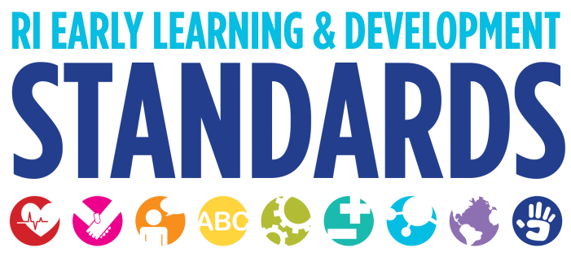
Strategies that Support Children in the Area of Literacy Development

Phonological Awareness
- Read aloud to children frequently and early in infancy. Even the youngest infants are stimulated by the sound of your voice and simple visual images.
- Engage children in daily experiences that promote phonological awareness. These include but are not limited to: playing rhyming games, singing songs, and chanting nursery rhymes; learning fingerplays; or reading and memorizing poems. 9
- Put phonological awareness games, activities, and rhyming books in learning centers around the room. Make phonological awareness part of the everyday classroom environment.10
- Use phonological awareness activities during transitions and routines. For example, sing the Name Game or say, "Everyone whose name starts with the sound of ‘ssss,’ get your coat," being sure to emphasize the sound, not the letter name. 11
- Play games that encourage children to segment the sounds in words. For example, “I’m going to say some words, and I want you to say back just the first little part. Can you say the beginning of shoe?” 12

Alphabet Knowledge
- Use well-written alphabet books that clearly illustrate the sounds of the letters with pictures of objects. 22
- Use reading aloud and shared reading to reinforce letter-name knowledge, inviting children to say what letter a new word starts with or having them find the word that starts with “S”. 23
- Provide daily opportunities for children to write, which supports their growing interest in and desire to learn the letters. As children write, teachers give them specific help when requested in identifying or forming letters. 24
- Expose all children to various ways an alphabet can appear in other languages. 25
- Provide multi-sensory experiences such as writing letters in sand or shaving cream; shaping letters out of play dough or pipe cleaners. 26

Print Knowledge
- Take children’s dictation, and focus on the sounds in the child’s words rather than the names of letters, saying the sounds in an elongated manner as you write. 20
- Use children’s attempts at writing to engage them in trying to sound out words and help draw their attention to words they know that begin with the same sound. “How do you spell Mom? Sounds like it starts like Marishka’s name.” 21

Comprehension and Interest
- Provide a variety of books of varying types so that children may develop and demonstrate preferences.
- Ask children to share what they thought about a book after reading it.
- Assist and support children in labeling their work.
- Encourage children to retell or re-enact stories.
- Make books with children by assembling collections of photos or magazine pictures that represent culturally diverse families and life experiences.

Dual Language Learners
- Choose books, music and other materials that reflect the range of cultures and languages of participating families so all children can see images and hear words and music with which they can identify.
- Learn and use words from the child’s home language at the program.
- Have books in the classroom that are written in the child’s home language.
- Have books that contain authentic images and text and nursery rhymes that reflect the cultures and languages of the children and families.
- Talk about books and images which represent both languages and cultures.

Emergent Writing
- Provide opportunities for young infants to use the fine motor muscles of their hands and fingers in manipulative play with rattles and other safe objects. Older toddlers enjoy manipulating crayons and other writing utensils. Allow children to scribble without their markings having to represent anything. First, they must enjoy the process of creating before they will be ready to intentionally write letters or draw pictures.
- As you write with children, draw their attention to symbols, such as periods and question marks. “I better put a period here so others will know to stop when they are reading it.” 1
- Encourage children to record their thoughts in pictures or writing in their personal journals. 2
- Ask children to sign-in each morning. The most meaningful word to any young child is his or her name. They are naturally motivated to see their name in print and spell their name when they are ready and find meaningful writing opportunities more enjoyable. 3
- Display the alphabet at eye level and functional print, such as children’s names, next to the classroom jobs for the week. Children can begin to recognize the letters in their own names and those of their friends, as well as other important words. 4
- Ask children to include print in their drawings like the authors in storybooks. 5
- Display their writing attempts as proudly as you do their pictures. Children learn about print by using it. They need encouragement: “You wrote me such an interesting note!” 6
- Set up play centers that incorporate reading and writing materials. For example, the housekeeping area can include empty food boxes and cans with labels, store coupons, play money, cookbooks, a telephone directory, message pads, and pencils. 7
- Provide manipulatives in all areas of the classroom to develop children’s manual dexterity and eye-hand coordination. 8

1 Diane Trister Dodge, Laura Colker & Cate Heroman. Creative Curriculum for Preschooler. Washington, DC: Teaching Strategies, 2002. 176.
2 U.S. Department of Health and Human Services, Administration on Children, Youth and Families, Head Start Bureau. The Head Start Leader’s Guide to Positive Child Outcomes: Strategies to Support Positive Child Outcomes. (Washington, D.C September 2003), 54.
3 The Head Start Leader’s Guide, 54.
4 The Head Start Leader’s Guide, 54.
5 The Head Start Leader’s Guide, 54.
6 The Head Start Leader’s Guide, 54.
7 Ann S. Epstein, The Intentional Teacher: Choosing the Best Strategies for Young Children’s Learning (Washington: NAEYC, 2007) 33.
8 The Intentional Teacher, 37.
9 The Head Start Leader’s Guide, 47.
10 The Head Start Leader’s Guide, 47.
11 The Head Start Leader’s Guide, 47.
12 The Intentional Teacher, 29.
19 Reading is Fundamental www.rif.org
20 The Head Start Leader’s Guide, 52.
21 The Head Start Leader’s Guide, 48.
22 The Head Start Leader’s Guide, 57.

