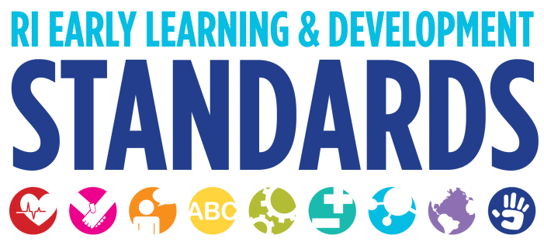

Strategies that Support Children in the Area of Physical Health and Development

Health and Safety Practices
- Very active toddlers need physical activity. Keep moving by dancing, jumping and walking together.
- Encourage frequent active play. Motivate children to engage in vigorous activities by showing enthusiasm, making it fun, and volunteering to do something active with them. 9
- Most preschool children are eager to perform personal care routines such as dressing and brushing teeth on their own. Teachers can support children’s growing independence as they plan the environment, provide materials, develop a schedule, and respond to individuals.10
- Practice healthy habits in group care, during socializations, and during home visits. Know when to wear gloves, wash hands, and take other health precautions.
- Know what resources are available in your community for families such as free outlet covers, free or low-cost clinics that offer health care and immunizations, and other useful supports.
- Be respectful of family beliefs and values around these healthy habits.
- Talk about safety throughout the day, such as why we hold the loop when we go for walks and follow classroom safety rules.

Gross Motor
- Provide sufficient space, toys, and equipment for child-initiated physical activities outdoors. Wheeled toys, slides, climbers, and other playground equipment sized for preschoolers can encourage children to pedal, climb, push, pull, balance, swing, hang, and slide. Cardboard boxes, tunnels, balance beams, jump ropes, plus a variety of balls and bats provide additional movement options.1
- Offer sufficient indoor space for gross motor activities so children can move without getting in each other’s way. Some examples follow:
~ Hallways are ideal for riding tricycles, rolling balls, tossing bean bags into baskets, playing relay games, building with large blocks, marching to music, and bowling (use plastic containers as pins).
~ A classroom loft lets children climb up stairs or a rope ladder, slide down a pole, swing (hang the swing on hooks when not in use), or jump off a low platform.
~ Provide room for music and movement activities; put mats on the floor for tumbling; play cooperative games using hula hoops, streamers, parachutes, and beach balls.
~ Participate in physical activities with children. This simple strategy allows adults to model movement skills, offer individualized assistance, learn how children approach and respond to physical challenges, and encourage children to practice and refine their skills. It also helps staff reduce stress and stay fit. 2
Tummy time" simply refers to the time that babies spend awake and playing on their stomachs. As a reminder, babies should never be placed on their stomachs to sleep. (For more information review the resources available from the Back to Sleep Campaign)
- A thoughtful and intentional approach to tummy time is important for several reasons: It gives infants a different perspective from which to see the world; It gives the infants the chance to practice and master important physical skills such as the ability to lift and support their heads, hold their heads steady, and turn their heads; They also develop strength in and control of their neck, shoulders, and back; These skills and abilities help infants prepare for rolling over, crawling, pulling up, and later, walking.
- Tummy time can be very unpopular with some young infants, who may prefer to be held or to be on their backs. It can help to keep these sessions very short or until the baby shows signs of distress. But for children who spend a lot of time sleeping on their backs, tummy time is important for physical development. It is a great way for babies to gain neck strength as well as upper-body and arm strength. Some families may be uncomfortable with allowing their baby to be on the floor for cultural or for health and safety reasons. Offer families ideas such as using a blanket, a crib mattress, or a parent's lap or chest. Remind families that tummy time should always be supervised
- Plan activities that promote perceptual-motor development:
~ Time awareness/coordination: Use nursery rhymes, chants, songs, and marches to help children learn to move to a steady beat.
~Body and visual awareness: Ask children to imitate body movements. Move as slowly as needed for children to achieve success. At first, model the movement and use verbal instructions. Later, just model or just give verbal directions. Gradually make the task more challenging by changing the speed, tempo, rhythm, or directions. 3

- Preschoolers should engage in at least 60 minutes and up to several hours of daily, unstructured physical activity and should not be sedentary for more than 60 minutes at a time except when sleeping. 4

Fine Motor
- Provide materials for a range of fine motor ability levels, including table blocks in several sizes, puzzles of varying complexity, computer software with several levels of complexity, small and large beads with thick and thin laces, and hand puppets and finger puppets. 5
- Offer and adapt activities to allow children to participate with success. When making bread, children can shape the dough into round loaves or braided ones; while making a group collage, children can tear or cut pieces of paper to add to the creation; while making puppets to re-enact a story, children can choose which materials to use and what to do with them. 6
- Plan an approach that allows children to be actively involved in routines. Make sure the schedule provides enough time for children’s participation. Children can fold napkins; put on and take off coats, hats, and boots; mix paint and wash paintbrushes; and pour from small pitchers. 7
- Encourage children to play simple games of hand-eye coordination such as aiming at a target with a beanbag or ball. 8
- Sing songs with hand movements such as "The Itsy Bitsy Spider" and "Twinkle, Twinkle, Little Star."
- Play the "thank you game" in which the child hands you an object, you take it and say thank you, and then you hand it back to the child. This grab-and-release activity not only supports fine muscle development, but also helps reinforce the pleasure of taking turns.

1 U.S. Department of Health and Human Services, Administration on Children, Youth and Families, Head Start Bureau. The Head Start Leader’s Guide to Positive Child Outcomes: Strategies to Support Positive Child Outcomes. (Washington, D.C September 2003), 107.
2 The Head Start Leader’s Guide, 107.
3 The Head Start Leader’s Guide, 107.
4 National Association for Sports and Physical Education, http://www.aahperd.org/Naspe/
5 The Head Start Leader’s Guide, 109.
6 The Head Start Leader’s Guide, 109.
7 The Head Start Leader’s Guide, 109.
8 Ann S. Epstein, The Intentional Teacher: Choosing the Best Strategies for Young Children’s Learning (Washington: NAEYC, 2007). 95.
9 The Head Start Leader’s Guide, 110.
10 The Head Start Leader’s Guide, 110.

